Dublin, Lower Southampton police departments receive state chiefs accreditation
Christopher Dornblaser
Bucks County Courier Times

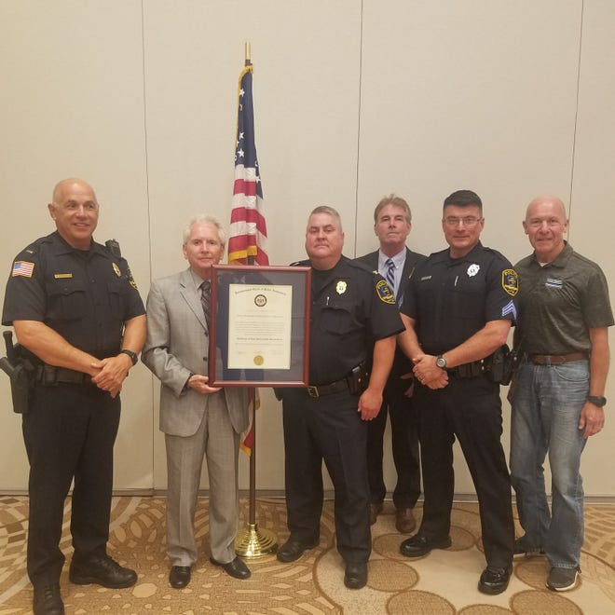
Two more Bucks County police departments are now among a small group of county police departments to receive accreditation by the Pennsylvania Chiefs of Police Association.
This month Dublin and Lower Southampton police joined the ranks of roughly 12 other county departments with that distinction. With accreditation, departments operate under policies that are deemed best practice by the state chiefs association. “We know that we’re following state law, we know that what we’re doing is in accordance with best practices with Pennsylvania," Lower Southampton police Chief Ted Krimmel said.
The Lower Southampton chief said getting accreditation was something the department has wanted to do for a while, but for various reasons could not make it happen.
Krimmel said Sgt. Matthew Bowman was assigned to handle the accreditation process in 2018. The process requires the department to send in proof of best practices to the state chiefs association. “He did a good job, we got it done in less than 2½ years," the chief said.
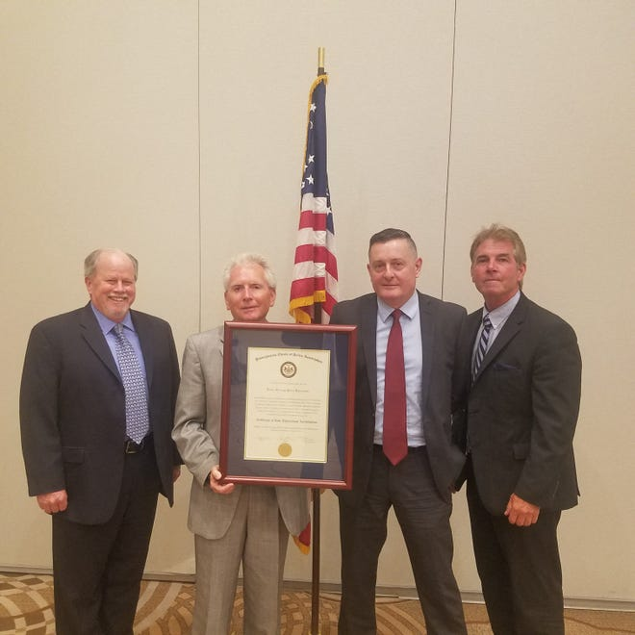
For departments pursuing accreditation for the first time, the process can take years. “Basically what we did was, we completely rewrote our policy guide from start to finish," Krimmel said.
The department now follows over 130 standards as set forth by the state chiefs association. “It definitely makes our job easier," Krimmel said. Now officers can search through the policies when handling a situation. “You name it, we have a policy for it," he said.
In addition to the policies, officials from the state chiefs agency did a site visit to the Lower Southampton police department, which kept getting delayed due to COVID-19. The chief said they had to make some changes to the police station to fit the standards set forth by the association. They didn't visit until May, according to Krimmel. The assessors did notice minor things that could be adjusted, which Krimmel said they rectified shortly after. The chief said they had to organize the evidence room and add cameras to the building, among other things.
After the assessors from the association visited the sites, they presented their findings to the accreditation board for review. Both Dublin and Lower Southampton were approved in early August. Krimmel said the department now has to maintain those standards. They will have to be re-accredited in three years. Dublin police were accredited in 2012 and 2015, according to Chief Mike Regan. The Dublin chief said the accreditation lapsed in 2018, so they decided to redo the process. The department's accreditation process began again in May 2019, he said. They had to provide proof that they were following the chiefs association policies for one year.
“It shows that we’re basically complying with every current policy and updating our policy," he said. Those policies include use of force, biased-based policing and use of body cameras, among other things. Regan said since the department had already been accredited before, it was largely already following the policies set forth by the state chiefs association.
Some of the assessors were able to check in with the department for some things virtually, but they could not do a site visit until July because of the COVID-19 pandemic, according to Regan. The Dublin chief, who became chief in 2018, said being accredited means the department is following best policy and procedures, and is "state of the art," with them. “In this day and age it’s very important," he said.
Scott Bohn, the executive director for the state chiefs association, said there are about 125 accredited police departments throughout the state. There are about 1,070 departments statewide. “These are departments that are meeting the highest standards and again are maintaining those standards,” he said.
The other Bucks County departments that are accredited are Bensalem, Bristol Township, Falls, Lower Makefield, Middletown, Newtown Township, Northampton, Quakertown, Richland, Solebury, Upper Southampton, and Warminster.

