West Chester police chief elected to top post of statewide law enforcement group
By Bill Rettew brettew@dailylocal.com
Apr 24, 2018 Updated Aug 16, 2018

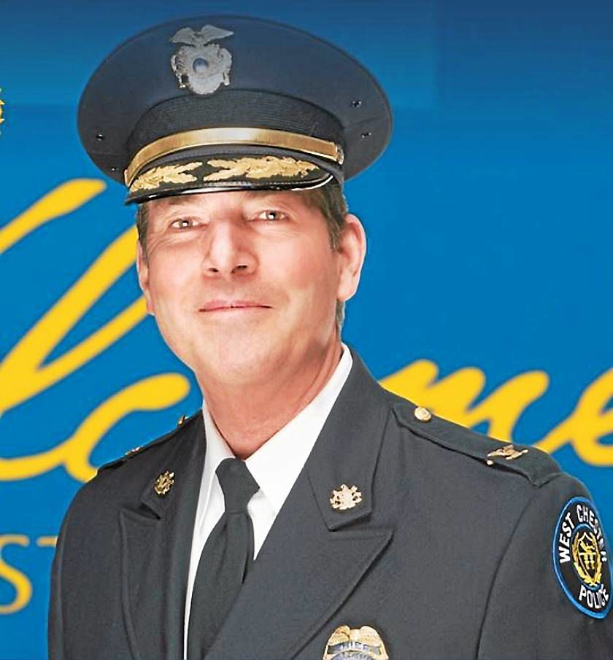

West Chester Police Chief Scott Bohn

Bohn will soon be sworn in as president of the Pennsylvania Chiefs of Police Association during a time that he said police from every corner of the state share mutual concerns and a common purpose.
“Our environments are constantly evolving,“ Bohn said. “Police service requirements have expanded beyond our traditional law enforcement duty.
“We are working in partnership with our members and our law enforcement communities to enhance public safety and the quality of life in our communities.”

Bohn said that the 16-member state board association is composed of police chiefs. The board will address concerns as varied as legislative issues, radar speed enforcement and school safety, as well as many other issues impacting police service and policing in the Commonwealth.
The Philadelphia sports fan said all issues facing police continue to evolve during a time of constant change and require active participation.
The active reader is always learning.
“Any time you can apply yourself to different ideas or views, it encourages or facilitates growth,” he said. “This is a very challenging but exciting time for law enforcement.”
Bohn lives with a bulldog in West Chester and said he is a homebody.
He is proud of West Chester Police who he said are some of the finest officers in the state.
Since he took over as chief in 1999, “the outstanding men and women of our department” have reduced serious crime by 58 percent.
“There is a marked increase in productivity and a significant decrease in liability and loss,” Bohn said.
“My officers and the officers in Chester County, as well as throughout the state are more than capable of meeting the challenge.”
Bohn enjoys living in the borough.
“West Chester is a tremendous and very unique community and I’m extremely proud of it,” he said.
The chief and association president is looking to the big picture on a statewide level.
“Leadership at a time of constant change involves our active participation on issues of public safety policy and legislation that will help shape the future of policing, provide professional development to our members and strengthen trust and respect of the policing profession in the Commonwealth,” the chief said.
The Pennsylvania Chiefs of Police Association is an organization comprised of more than 1,200 command-level law enforcement officers which includes not only chiefs of police, superintendents and commissioners, but also the commanding officers of federal, state and industrial agencies. The association’s goal is to be regarded as a world-class resource for professional law enforcement leadership and a respected voice for Pennsylvania’s law enforcement community.

