Opinion

Take it from a cop: Legal marijuana will cloud enforcement of highway safety | Opinion
Posted Aug 30, 8:00 AM
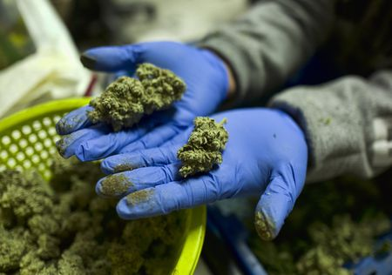
In this April 4, 2019 photo, a cannabis worker displays fresh cannabis flower buds that have been trimmed for market in Gardena, Calif. AP
By Express-Times guest columnist
By Scott L. Bohn
As executive director of the Pennsylvania Chiefs of Police Association and a former member of the state Health Department’s Medical Marijuana Advisory Board, I would like to express my concerns, and those of many of our members, about the legalization of marijuana and the relative effects on public safety in or communities.
I believe marijuana legalization in Pennsylvania will pose significant challenges for law enforcement resulting from the unanticipated consequences it has on crime and public safety.
In our meeting with Lt. Gov. John Fetterman, we supported decriminalization. There is an important distinction to be made here for the state’s residents. Legalization of marijuana is the process of removing all legal prohibitions against it. Marijuana would be available to the adult general population for purchase and use at will, similar to tobacco and alcohol. Decriminalization is the act of removing criminal sanctions against an act, article or behavior.
There are insufficient data to determine the true impact of legalized marijuana on crime and safety. However, studies in Colorado show:
- High-potency THC from marijuana hash oil extractions, which are used in making legalized, laced edibles and beverages, has led to overdoses, potential psychotic breaks, and suicide attempts.
- Youth use and addiction rates have increased due to ease of accessibility, and there is great concern about the significant health impacts of chronic marijuana use on the youth.
- Banking systems are unavailable to the marijuana industry because of federal laws, creating a dangerous level of cash that can lead to crime.
- Difficulties in establishing what is a legal marijuana operation have created problems in conducting investigations, determining probable cause and search and seizure procedures.
- Marijuana illegal trading through the black and other markets has not decreased. Diversion across state boundaries has created issues for states that do not have legalized marijuana laws.
- Detecting driving under the influence of marijuana is a significant challenge for law enforcement. Currently, there is no roadside test for marijuana intoxication.
- Many states have had difficulties caused by conflicting state legislation and local ordinances, policies, and procedures. The situation is even more complex because marijuana remains a Schedule I controlled substance under federal law.
One of the most salient concerns we have relates to the consequences of drug-impaired driving. We have all witnessed our share of crashes and traffic congestion, as well as vehicular, pedestrian and cyclist fatalities. Law enforcement officials are uniquely qualified to discuss the issues and concerns related to impaired driving.
Our efforts to curb drunk driving have met with a great deal of success over the last decade, but drug-impaired driving is not the same as alcohol-impaired driving, and our understanding of the impairments due to drug impairment is limited.
Alcohol is unique among impairing drugs in that there is a documented correlation between blood levels and levels of impairment. This does not exist for other drugs and it has been shown to be nonexistent for THC in marijuana. It is not possible to currently identify a valid impairment.
Scott L. Bohn is executive director of the Pennsylvania Chiefs of Police Association.

