Less than half of the Lehigh Valley’s police departments have any kind of accreditation
By CHRISTINA TATU
THE MORNING CALL |
AUG 05, 2020 AT 7:00 AM
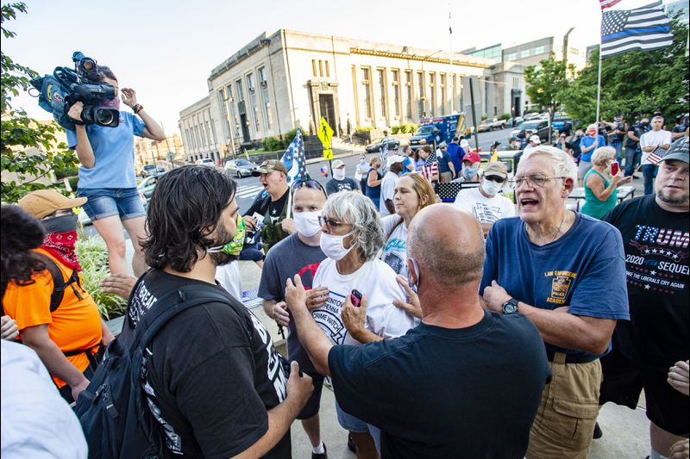

Protesters gather at Allentown City Hall
Both sides exchange words. Back the Blue and Black Lives Matter groups were in attendance. at Allentown City Hall on Wednesday. Allentown City Council will consider a resolution Wednesday calling for various measures related to police reform, oversight and divestment of resources. (April Gamiz/The Morning Call)
1 / 24
Getting state or national accreditation is voluntary for police departments, but advocates say it holds them more accountable by requiring departments to undergo regular reviews of their policies and arrest records.
In the Lehigh Valley, however, more than half of the police departments don’t have any type of accreditation, and only one department is accredited by the Commission on Accreditation for Law Enforcement Agencies, or CALEA, a national group that also certifies law enforcement agencies in Canada and

The Lehigh Valley has 42 municipal police departments and only 14 of them are accredited by the Pennsylvania Law Enforcement Accreditation Commission. Those departments include Allentown, Bethlehem and Easton. In addition, only one university police force in the area is accredited by the state — Lehigh University.
At the national level, Bethlehem is the only local department to be accredited by CALEA, though Pennsylvania State Police, which patrols many Lehigh Valley communities, also has achieved the accreditation.

Allentown City Council debates police reforms »
That could change as cities reexamine their police departments amid a national movement to make officers more accountable to the communities they serve. After the death of George Floyd in Minneapolis triggered worldwide outrage over another unarmed black man dying at the hands of police, activists in the Lehigh Valley and across the country called for releasing the disciplinary records of officers and defunding departments. While accreditations address some concerns by raising the bar on police training and record-keeping, the money and manpower required put the systems out of reach for some departments.
“I suspect as we move forward more and more agencies will become accredited. We are seeing an uptick in people inquiring about accreditation and accreditation status,” said Scott L. Bohn, executive director of the Pennsylvania Chiefs of Police, which along with the Pennsylvania Commission on Crime and Delinquency, oversees the state’s accreditation process.

Accreditation from both the state and national organizations address some of the issues that have come up as communities across the country consider police reform. For example, both groups require an officer use only the amount of force reasonably necessary to make an arrest or to defend themselves. They also ban chokeholds unless an officer is confronted with deadly force, and they require officers to undergo training to prevent racial bias.
Pennsylvania is one of 34 states to offer accreditation. There are more than 1,000 law enforcement agencies in the Keystone State, 120 of which have received state accreditation since the program was implemented in 2001.
As part of the process, a group of independent law enforcement officials developed best practices and standards. To be accredited, a police department must prove through record keeping and yearly reviews that those standards are being followed.
“We do a number of on-scene assessments of these agencies. Everything from top to bottom, including the physical location, their policies and practices. Over 135 standards have to be met,” Bohn said.
Slate Belt Regional Police recently went through the process, achieving state accreditation in March.
“Your policies, which are the backbone, have to be just so. Then your officers’ performance has to be rated, whether it’s report writing, standard of training,” said Slate Belt Regional Police Chief Jonathon Hoadley. “It goes the full gamut and opens us up to be looked at in a critical way, so people understand we take this very seriously and we have a standard we have to operate by.”
Hoadley’s department started the process in 2016, but it petered out when there was a change in leadership. Hoadley took up the process again in March 2019 after he became chief.

In January, representatives from the Pennsylvania Chiefs of Police spent several days reviewing the department’s policies, and examining its equipment, guns, patrol cars and even temporary holding cells, Hoadley said.
They also spent time with officers on their patrols in Plainfield Township, and Wind Gap and Pen Argyl boroughs.

Although the department has had a use-of-force policy since its inception in 2015, Hoadley said accreditation has led to some updates. Per state guidelines, he is adding a section requiring officers to intervene if they see a colleague using excessive force — a policy advocated by reformers and now under consideration in Allentown. Bethlehem already has such a policy.
“I can speak for everyone here that they would intervene if they saw something like that, but now it’s here in black and white,” Hoadley said.
Accreditation requires agencies to establish a framework for evaluating procedures, and it requires them to keep meticulous records on the number and type of arrests made, including a report any time force is used during an arrest.

Assessors do a final review of a department’s files to make sure the state’s standards are met before bestowing accreditation, which is valid for three years, with annual reviews.
Advocates say accreditation can decrease a department’s exposure to lawsuits by ensuring they are following the most up-to-date best practices.
Having best practices in place aids a police chief in managing a department, providing facts and figures for making informed decisions, said Paul Macmillan, regional program manager at CALEA, which follows an accreditation procedure similar to the state’s.

There are 14 agencies in Pennsylvania with CALEA certification and more than 800 agencies internationally. Bethlehem took the step in 2007, prompted by a botched drug raid at a South Side home in which a federal jury found the police department used excessive force. During the 1997 raid, police shot John Hirko Jr. 11 times, killing him, and threw a flash bang grenade that burned down the house as Hirko’s girlfriend narrowly escaped.

John Hirko Jr.
Bethlehem settled with Hirko’s family for $7.89 million, writing the final check in 2015.

Mayor Robert Donchez has said the raid prompted the department to become more community-minded. The national recognition, he said, holds Bethlehem police to a higher standard than other departments. The policies and procedures that accredited departments must follow build trust among people in the community, Macmillan said. “They know what to expect of their officers and the officers know what to expect when they have to handle certain situations,” he said. “We have a saying, ‘standards build trust.‘” But critics point out the process can be time-consuming and expensive and some doubt it addresses like building better relationships with the community.

Tony Phillips, president of the Allentown NAACP, said accreditation is “just a piece of paper” listing a department’s policies and procedures. Policies do nothing to guarantee an officer’s character, he said. Phillips, a former Allentown police officer who once ran for mayor, thinks police need more hands-on training. They also need to spend more time doing foot patrol in the neighborhoods they serve so they are building relationships and creating trust among residents.

He believes neither of these issues is addressed through accreditation.
One way to ensure police reform would be to make state and federal money for police dependent on a department’s overall performance, he said.
“If they are going to give you a bonus for doing a great job, then you’re going to work your tail off,” he said.

Obstacles
For small agencies, the accreditation process can be overwhelming and financially out of reach.
CALEA charges an initial fee of $8,475 to $19,950, depending on the size of the department. After that, it charges a yearly fee that ranges from $3,470 to $5,765.
State accreditation is much less expensive, starting at $350. Once accreditation is achieved, departments pay $1,000 a year to keep their status. There are also state grants and subsidies to pay for the fees, Bohn said.
Aside from the money, it also takes time, said Maria Haberfeld, a professor of police science at John Jay College of Criminal Justice in New York. Ensuring a department complies with all the standards is often a full-time job and smaller departments might not have the manpower to spare. That, Haberfeld said, could create legal issues.
“The moment you have accreditation, you are subject to possible liability if you do not follow those recommendations,” she said. “If someone misplaces something and it’s supposed to be in a given folder, it’s a liability issue.”
She believes there hasn’t been a push to require accreditation because there are so many police departments in the United States — as many as 18,000 — a mandate would be difficult to enforce.

An executive order signed by President Donald Trump in June encourages departments to get accredited and calls for the attorney general to review credentialing agencies. The order encourages police to address policies and training pertaining to use-of-force and de-escalation techniques and to adopt performance management tools, such as an early warning system that would help identify officers who may require an intervention.
The order also directs the attorney general to create a database that federal, state and local law enforcement agencies would share, containing firings, convictions or civil judgments of officers for improper use of force.
The order does not require departments to become accredited, but Macmillan thinks it will spur departments to go through the process.
“We are still waiting to hear more about what exactly this means, but I think there will be more interest in the accreditation process both at the national and state level,” he said.
Morning Call reporter Christina Tatu can be reached at 610-820-6583 or ctatu@mcall.com.

Accredited agencies
According to Pennsylvania Police Chiefs of Police Association website, these Lehigh Valley departments earned state accreditation: Allentown, Bethlehem, Bethlehem Township, Colonial Regional, Easton, Forks Township, Lehigh University, Lower Saucon, Northampton County Sheriff’s Department, Palmer Township, South Whitehall Township, Slate Belt Regional, Upper Macungie, Upper Saucon and the Pennsylvania State Police.
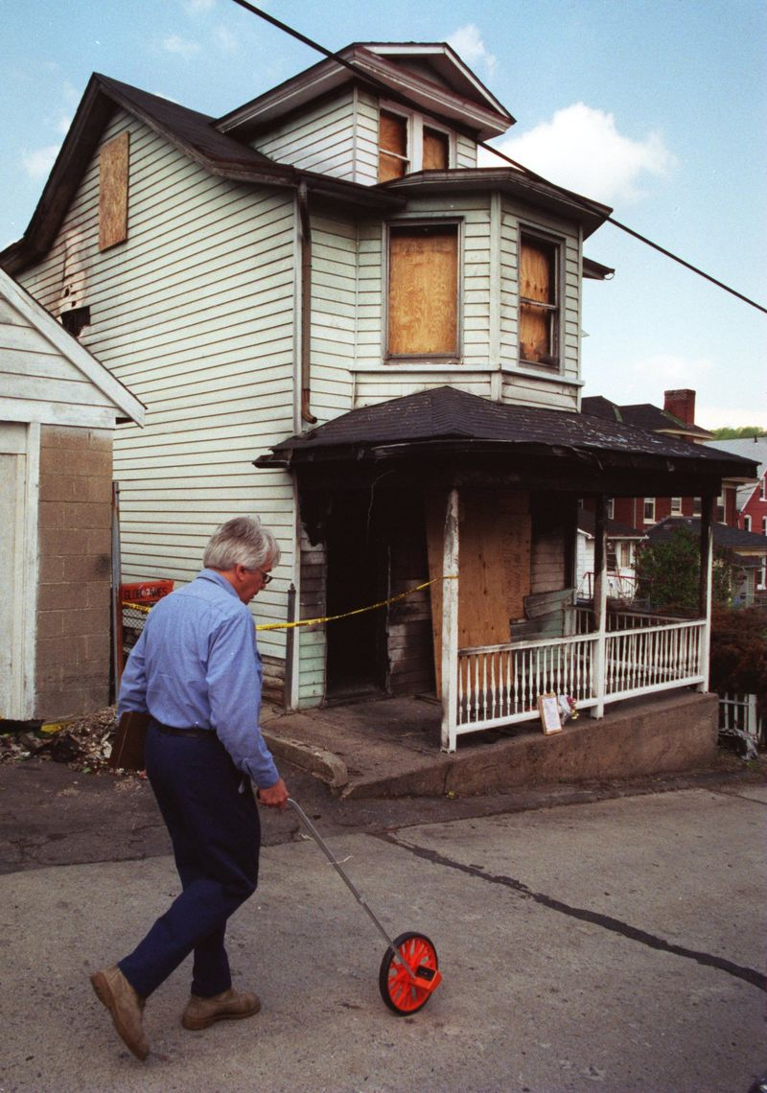
The burned out remnants of John Hirko's home, where Bethlehem police threw a flash grenade that started a fire in 1997. (TMC)

Christina Tatu

CONTACT

A Stroudsburg native, Christina Tatu came to The Morning Call in 2015. Before that, she worked at the Pocono Record and New Jersey Herald as a general beat reporter covering multiple municipalities and school districts. Now she writes about the City of Easton, Lower Nazareth and Nazareth Borough.

