Pennsylvania lawmakers take first step toward police reform. What comes next?
By SARAH M. WOJCIK
THE MORNING CALL |
JUL 19, 2020 AT 6:00 AM
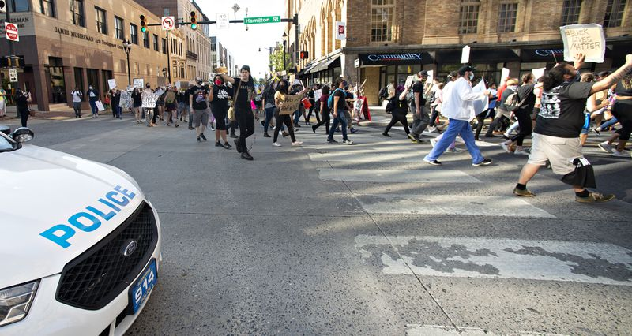
Protestors march down Hamilton and up Sixth Street during a protest Monday, July 13, 2020, in response to a video that showed an Allentown police officer kneeling on a man's head. (Rick Kintzel/The Morning Call)
Police reform efforts in the state aren’t new, but Black leaders say the momentum propelling them into reality is.
Legislation aimed at resolving long-standing issues in policing, including the need for more training and the ability for agencies to share disciplinary information about individual officers, have languished in the past. But Black leaders say the killing of George Floyd in Minneapolis on May 25 and the protests that followed have given new energy in the push for change.

“I think we are in the moment and possibly on the precipice of America’s third Reconstruction,” said Gregory Edwards, a pastor and community leader in Allentown.
DA: Allentown police were justified in takedown »
Gov. Tom Wolf signed House Bill 1841 and House Bill 1910 into law on Tuesday. The bills tackle police training, mental health access and the sharing of officers’ records which many departments had tried in some form. They received the backing of the Pennsylvania State Troopers Association, the Pennsylvania Chiefs of Police Association as well as bipartisan support in the Legislature.

House Bill 1841 requires an officer’s employment history to be disclosed to other law enforcement agencies and frees the previous employer from liability for sharing such information. It will establish a database, so agencies can screen prospective hires.

House Bill 1910, meanwhile, beefs up use-of-force training and requires officers involved in such incidents to undergo mental health evaluations, with a focus on identifying post-traumatic stress disorder. The law would add bias and other training to help officers working in diverse communities.

Edwards believes the tipping point came from the diversity of those calling for change. It’s not just Black people calling for reform, Edwards said, but people of all races and ages.
“I am heartened by the fact that we have many white allies,” he said. “I’m really excited about this moment and our younger generations who are leading us.”
Michael Laws, vice chair of the Pennsylvania Democratic Black Caucus, described the electricity within the Legislature as lawmakers took on the bills. He pointed to one moment as the catalyst: on June 8, when a group of Democratic lawmakers took the floor at the beginning of a session, placed a Black Lives Matter banner next to the speaker’s podium and called for systematic change. From there, real debate and progress began with renewed commitment, he said.
Reform most recently was discussed after the killing of 17-year-old Antwon Rose II on June 19, 2018, by East Pittsburgh police. White officer Michael Rosfeld was acquitted of homicide in 2019, and bills drafted in the wake of Rose’s death stalled in the Republican-controlled Legislature.
“I do think a lot of this came from the action of these bold and courageous legislators,” Laws said. “They basically said, ‘We need to do something. We need to draw a line in the sand and make sure we’ve got change coming.‘”

Falling short of real reform
The new mandates are the kinds of things that the Pennsylvania Chiefs of Police Association and many other law enforcement leaders have backed for years, said Scott Bohn, the association’s executive director.
“I don’t think there’s a police chief in the state who wants to hire a bad police officer,” Bohn said, referring to the officer database that will be created under House Bill.
Allentown police Chief Glenn Granitz Jr. also had high praise for that part of the legislation, saying he has pushed for a better hiring system since becoming chief last fall. The measure has support from community members and law enforcement alike.
But even as other states move to strengthen the public accountability of officers, the Pennsylvania legislation does not allow the sharing of records with the public or anyone outside of law enforcement. While it’s a start, it doesn’t go far enough, according to many advocates for police reform, including Edwards.
“Any officer involved in any case of police brutality or disciplined for the like should have their name placed in a public database,” Edwards said. “This furthers transparency, trust and accountability between police departments and the community.”
State Rep. Mike Schlossberg, D-Lehigh, said he understands the arguments against making such information public but believes that, especially in cases of police brutality, there must be accountability beyond law enforcement because that promotes trust.
The state’s largest police unions have opposed making the records public.
Bohn, from the police chiefs association, noted “individuals have rights to their reputation.” Airing personnel records like this could ensure a former officer struggles to find a job in a new field, he said.
“If they’re not suitable for a position of public trust as a law enforcement officer, it should not preclude them from seeking gainful employment in another occupation,” Bohn said.
The details of how these requirements will be rolled out and what kind of resources departments will receive to implement them is still being worked out.
While many forward-thinking departments already do mental health checks or provide training to help officers identify and address implicit bias, Bohn thinks it beneficial to create a uniform requirement for the state’s 1,076 police departments. But he worries that some of the well-intentioned changes won’t come with the means to make them a reality.
“We don’t want to be looking at the wrong end of an unfunded mandate,” Bohn said. “If we create a public expectation here, we’ve got to make sure we’re ready to meet that expectation.”
Granitz called the training “a positive first step” but also expressed concern over funding. Departments cannot foot the bill for more training without some help, he said. That would force cutbacks in other parts of the department.
That is just what thousands of protesters calling for defunding police departments would want — cutbacks that would prompt police departments to restructure. Protesters outside Allentown City Hall during a City Council meeting Wednesday night, demanded the reallocation of $25 million in police department funds to other areas that benefit the community.
Shifting police funds to other social and community programs would take some of the load off police officers and strapped departments, Edwards and others have said. Edwards believes social programs can reduce crime and that and those in the midst of a mental health crisis, substance abuse issue or homelessness are better served by social workers than law enforcement.
“A budget is a moral document,” Edwards said. “It points to a city’s values and guiding principles.”

What’s next?
Edwards hopes reform efforts continue and that the success in having the first two bills move quickly is not seen as a job completed.
The most substantial police reform bills, which would include banning chokeholds, narrowing the instances in which lethal force is permitted and appointing special prosecutors to investigate police shootings, haven’t budged. Those bills are part of the Democrats’ platform, but are a much harder sell across the aisle.
Schlossberg called the bills that Wolf just signed, the “easiest stuff in the world.”
“From a systematic level, this is not enough,” he said.
Schlossberg is in favor of legislation addressing the scope of lethal force and adding special prosecutors to any police shooting probe. These measures promote de-escalation and accountability but are likely to move through the Legislature much more slowly, he said.
The most lasting and important kind of change can’t be legislated, he said. It requires a cultural shift.
“A cultural change has to take place at the top,” he said. “There is no short-term fix. This is a long-term project.”
Morning Call reporter Sarah M. Wojcik can be reached at 610-778-2283 or swojcik@mcall.com.
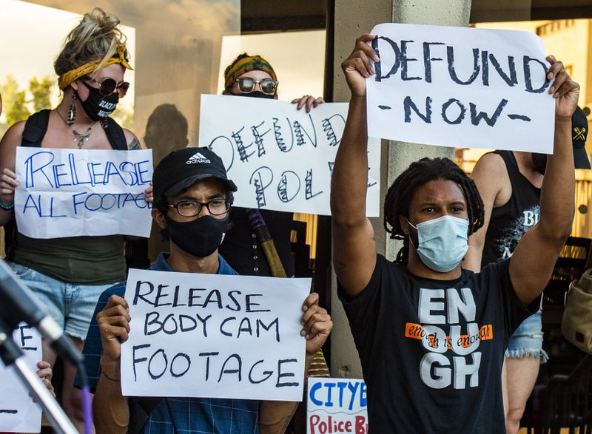
Protesters outside Allentown City Hall Wednesday, as Allentown City Council met to discuss police reform proposals. (April Gamiz/The Morning Call)

