Montgomery Township police receive 'premier' status in state accreditation
Christopher Dornblaser
Bucks County Courier Times

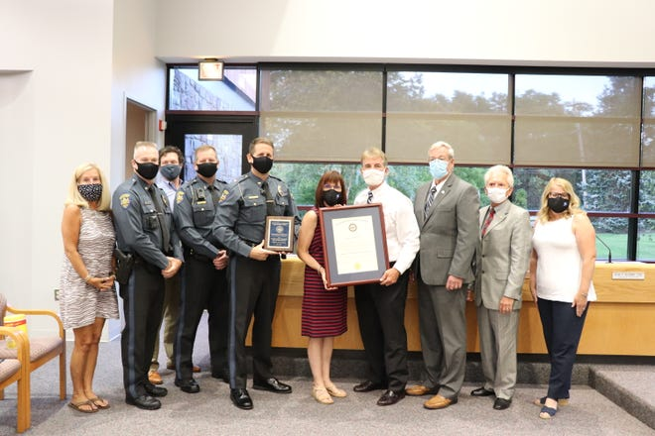
Montgomery Township police now have a distinction very few police departments in Pennsylvania have.
The department is one of 14 statewide to receive "premier" status after recently achieving their fifth accreditation since 2004.
“It’s really a good program, we’re really fortunate we jumped in on this at the ground level," Chief Scott Bendig said.
Departments accredited by the Pennsylvania Chiefs of Police Association follow guidelines deemed best practice by the organization. Only about 10% of departments are accredited throughout the state.
In order to maintain that accreditation status, departments must undergo re-accreditation every three years, to prove that they are continuing to follow the guidelines, even as those guidelines change over the years.
“It covers a litany of things to say the least," Bendig said.
More: Police departments receive state chiefs accreditation
The chief said the department was designated a "premier" department, meaning there no were no deficiencies noted during each of the accreditation processes since the Montgomery Township department first became accredited in 2004.
“We’re doing our best to raise that bar as high as we can as a profession," he said.
In order to stay accredited the department must provide proof that it is abiding by the policies set for by the association. Those policies have changed over the years.
For example, Bendig said the chiefs association recommended training on less lethal components yearly following George Floyd's death in May.
Previously training on such devices was done at the recommendation of the manufacturer, which would sometimes be every two years, according to the chief.
Bendig said keeping up with the latest policies challenges the department to do be better.
“We’re very proud of the work that our officers do," he said.
The department's command staff keeps up with the latest changes and implements them in the department, he said.
“It really is a holistic approach," Bendig said.
The policies include things such as biased-based policing, use of force issues, pursuit management and hiring practices.
The chief thanked township officials for supporting the department in its efforts to continue being accredited.
The department is one of eight Montgomery County police departments to receive the premier status. The others are Abington police, Douglas Township police, Horsham police, Lower Salford Township police, Upper Dublin police, Upper Gwyned police and Upper Merrion Township police, according to the state chiefs association.

