*Incident Response to*

*Terrorist Bombings*



Hosted by:

Montour County Emergency Management

Class date:

**January 17, 2020**

**5pm-9pm**

Location:

Washington Fire & Hose Co.

532 Railroad St.

Danville, Pa. 17821

Online Registration: PaTrain

OR

Email at contact information below.

For questions, please contact:

Name: Montour County EMA

Phone: (570) 271-3047

Email: eburkland@montourco.org

This training is sponsored by the Union County Sheriff’s Department, the New Mexico Tech – Energetic Materials Research and Testing Center with funding provided by the United States Department of Homeland Security.

Incident Response to Terrorist Bombings (IRTB) was developed by the New Mexico Institute of Mining and Technology (New Mexico Tech) and provides first responders with the skills necessary to recognize and report a potential incident involving explosives.

The course provides participants with an understanding of the terrorist threat, information on recognition and capabilities of energetic materials (explosives and incendiaries) that could be used in a terrorist attack, and appropriate response protocols.

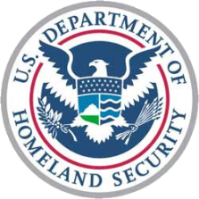

Topics covered include but are not limited to:

* Weapons of mass destruction, terrorism and the acquisition of information, materials and tools
* Recognition of energetic materials, devices and device components
* Incident response scenarios
* Response, scene control, safety and evidence collection