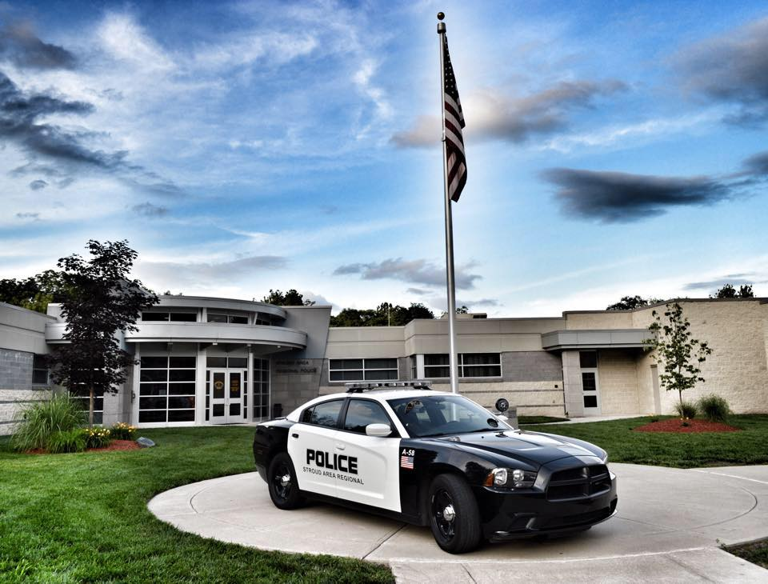Pre-Test Application Packet

**Application Packet contains:**

* General Information
* Hiring Requirements
* Pre-Test Application
* Written Exam date, time, and location
* Physical Fitness Test date, time, location
* Physical Fitness Test requirements
* Informed Consent Form- Keep with you, and bring to physical fitness test
* Medical Clearance Form- Keep with you, and bring to Physical Fitness Test

**SARPD offers a competitive salary and benefits package:**

* **2024 starting salary $57,454**
* **Longevity**
* **9 Paid Holidays**
* **8 Personal Days**
* **Up to 28 Vacation Days**
* **15 Sick Days**
* **Pension**
* **457 plan**
* **Health benefits/Insurance**

**Applicants must meet all minimum requirements in order to participate in the testing process:**

* Must possess the minimum requirements of a high school diploma or equivalent,
* Have a valid Pennsylvania driver’s license at time of appointment,
* Be no less than 21 years of age at the time of appointment,
* Have a primary residence with in a fifty (50) mile radius of Headquarters at time of appointment,
* Meet all MPOETC required background, physical and psychological standards.
* ACT 120 is not required to participate in this hiring process.

A valid photo ID (Driver’s License) is required at all tests. **THERE ARE NO MAKE-UP DATES, TESTS WILL NOT BE RESCHEDULED.**

The testing process will follow the phases listed below:

1. **PRE-TEST APPLICATION**

A pre-test application must be filled out completely and submitted, along with a $75.00 non-refundable processing fee (check or money order only- NO CASH) made payable to the Stroud Area Regional Police Department by 12PM on Friday, October 6th, 2023. **NO applications will be accepted after 12 PM on Friday, October 6th, 2023.**

1. **WRITTEN EXAM**

**Date:** Thursday, October 12th, 2023

**Time:** Test starts at 6:00 pm. Candidates must arrive by 5:45PM

**Location:** Stroudsburg Middle School

207 Mountaineer Drive

Stroudsburg, PA 18360

**IMPORTANT INFORMATION ON THE WRITTEN EXAM:**

**Check in time for the written exam begins at 5pm and NO APPLICANTS WILL BE ALLOWED INTO THE TESTING SITE AFTER 5:45 pm. The written exam will begin at 6pm. Applicants need to produce a valid photo ID to be admitted into the exam.**

**\*\*\*\*\*Applicants must score a 70% or higher on the written test, in order to continue in the application process and participate in the physical ability test. Written test scores will be posted on our website with the applicant’s test ID # only. Please keep the test ID# that you are assigned the day of the written test.**

**\*\*\*Study Guides and Practice Exams can be found online at** [**www.mccanntesting.com**](http://www.mccanntesting.com) **under resource center\*\*\*\*\*\*\*\*\*\*\*\*\*\*\*\*\*\*\*\*\*\*\*\*\*\*\*\*\*\*\*\*\*\*\*\*\*\*\*\*\*\*\*\*\*\*\*\***

**Candidates MUST bring #2 pencils with them to the testing site.**

1. **Physical Ability Test**

**Date:** TBD

**Time:** TBD

**Location:** TBD

* You will need your signed **Medical Release Form**, signed **Informed Consent Form** and a **valid photo ID** to be admitted for testing.

|  |  |
| --- | --- |
| **300 Meter Run** | **66 Seconds** |
| **Sit-ups** | **30 Reps in 1 Minute** |
| **Push-ups** | **25 Reps in 1 Minute** |
| **Vertical Jump** | **15.5 Inches** |
| **1.5 Mile Run** | **15 Minutes 54 Seconds** |

**The physical Ability test consists of:**

**IMPORTANT INFORMATION ON THE PHYSICAL ABILITY TEST:**

You must be medically cleared by your physician to safely perform the test. You are required to take the “Medical Release Form,” enclosed in this Application Packet to your Physician and have him/her sign it. You must bring the signed Medical Release Form to the Physical Fitness test.

**IF YOU ARRIVE AT THE PHYSICAL ABILITY TEST WITHOUT A MEDICAL RELEASE FORM SIGNED BY YOUR PHYSICIAN, YOU WILL NOT BE ALLOWED TO TEST.**

**DO NOT ENTER THE TESTING SITE. You will be met outside of the gates to the Location To Be Determined by an SARPD officer.**

**MEDICAL CLEARANCE FOR PARTICIPATION**

It is the responsibility of each applicant to possess an acceptable level of physical readiness which insures that the applicant is, at all times, at a level of physical readiness necessary to perform the essential tasks of a police officer.

In order to insure that each applicant can perform his/her duties safely and effectively without undue risk to themselves or the public, the applicant is required to take the Physical Fitness Tests as part of the selection procedures. This test was designed using the guidelines of the “American College of Sports Medicine” and the “Cooper Institute for Aerobics Research.”

***Questions regarding this form or the Physical Ability Tests shall be directed to:*** Mike Grogan, Physical Fitness Consultant, Pennsylvania Chiefs of Police Association, 3905 North Front Street, Harrisburg, PA 17110, pafitcop@yahoo.com or (717) 579-7299.

**MEDICAL RELEASE FORM**

Dear Physician:

In order for ____________________________________________, an applicant for

(Applicant’s name)

the position of police officer, to participate in the physical fitness test, it is necessary for him/her to obtain clearance from a licensed physician. Please review the test guidelines on the reverse side of this form and sign the appropriate line below. Additional space is allowed for comments, including any limitations on applicant’s participation.

All testing is monitored by certified fitness coordinators. Testing is ended when the applicant meets the requirement, i.e. if the standard is 20 push-ups, the test ends when the applicant meets that standard. Any additional push-ups will not be counted. The test is of the pass/fail type.

I have examined the applicant whose name is listed above.

The applicant **MAY** participate in the Physical Fitness Tests.

Physician’s Signature: _____________________________

**OR**

I have examined the applicant whose name is listed above.

The applicant **MAY NOT** participate in Physical Fitness Tests.

Physician’s Signature: _____________________________

Comments: ________________________________________________________________________________________________________________________________________________________________________________________________________________________________________________

**Informed Consent Form**

The undersigned hereby gives informed consent to engage in a series of procedures relative to taking a battery of exercise tests, and participating in a variety of physical activities. The purpose of the testing is to determine physical fitness, cardiovascular function, and health status. All exercise testing and physical activity sessions will be supervised and monitored by trained exercise technicians. These activities include walking, running, weight training, and callisthenic exercises performed in either field or gymnasium settings. I am aware of the possibility that certain detrimental physiological changes may occur during exercise and exercise testing. These changes could include heart related illness, abnormal heart beats, abnormal blood pressure, and in rare instances, a heart attack. If abnormal changes were to occur, the staff has been trained to recognize symptoms and take appropriate action, including administering CPR and first aid.

I have read this form and understand that there are inherent risks associated with any physical activity and recognize that it is *my* responsibility to provide accurate and complete health/medical history information. Furthermore, it is my responsibility to monitor my individual physical performance during any activity and to alert the supervising exercise technician of any pain, discomfort or adverse effects I may experience. I hereby waive and release PCPA, its testers, trainers, helpers and other participants and persons who will be assisting in this testing, whether employees of PCPA or independent contractors or consultants, and the owners of the locations where the testing is held, its officers and employees or agents from any and all liability of any nature for injury, damage or any other loss resulting from the testing and expressly assume the risk of such damage, injury or loss while engaged in any testing.

I give informed consent for testing data to be recorded to determine my state of physical readiness as it applies to the essential job functions of a Pennsylvania police officer.

Print Name: ____________________________________________

Signature: _____________________________________________

Date: _____________________________________________

|  |  |  |  |  |  |  |  |  |  |  |
| --- | --- | --- | --- | --- | --- | --- | --- | --- | --- | --- |
| **Pre-Test application for the position of Police Officer** | | | | | | | | | | |
| **Applicant Information** | | | | | | | | | | |
| **Full Name** |  | | | | | | | | | |
| **Present Street Address** | | |  | | | | | | | |
| **City** |  | | | | | **State** | |  | **Zip Code** |  |
| **Mailing Address** | |  | | | | | | | | |
| **City** | |  | | | | | | | | |
| **Home Phone** | |  | | | | | | | | |
| **Cell Phone** | |  | | | | | | | | |
| **Email Address** | |  | | | | | | | | |
| **Are you a citizen of the United States?** | | | | **YES** | **NO** | | **If no, date Naturalized?** | | | |
| **Are you at least 21 years of age?** | | | | **YES** | **NO** | |  | | | |
| **Are you Pennsylvania Act 120 certified?** | | | | **YES** | **NO** | | **If yes, date graduated?** | | | |
| **Will you be claiming Veteran’s Preference? If so attach DD-214** | | | | **YES** | **NO** | |  | | | |

|  |  |  |  |
| --- | --- | --- | --- |
| **Emergency Contact:** | | | |
| **Name:** |  | **Phone #:** |  |
| **Address:** |  | | |

|  |  |  |  |
| --- | --- | --- | --- |
| **Disclaimer and Signature** | | | |
| ***I certify that all of the information submitted by me on this application is true and complete, and I understand that if any false information, omission, or misrepresentations are discovered, my application will be rejected and if employed by SARPD, my employment will be terminated.*** | | | |
| **Signature:** |  | **Date:** |  |

*Stroud Area Regional Police Department is an Equal Opportunity Employer*