**Stroud Area Regional Police**

**NOW HIRING: Police Officers!!!**

**Hiring Announcement: Seeking Act 120 and Non-Act 120 Applicants**

Stroud Area Regional Police Department is currently accepting applications to establish a hiring eligibility list. Applicants do not need an Act 120 certification to apply or proceed through the hiring process. If an applicant is selected, SARPD will sponsor the applicant to attend the police academy. The written test will be given on **Thursday, October 12th, 2023 at 6p.m**. at the Stroudsburg Middle School.

Anyone interested in applying to SARPD is encouraged to go to our website, *www.sarpd.com*, download a Pre-Test Application Packet, and submit your application, along with a **$75.00** check or money order payable to Stroud Area Regional Police, 100 Day Street, East Stroudsburg, PA 18301, no later than **Noon on Friday, October 6th, 2023.** Applications can also be picked up at our headquarters, Monday through Friday, 8 am to 4 pm.

**Minimum Job Requirements:**

* Must be a U.S. Citizen
* Must be 21 years of age at time of appointment
* Must possess a high school diploma or equivalent
* Must possess a valid Pennsylvania driver’s license at time of appointment
* Have a primary residence within a fifty (50) mile radius of our department at time of appointment
* Must meet all Municipal Police Officer’s Education and Training Commission required background, physical and psychological standards

**Salary and Benefits**

* $57,454 as a Probationary Employee (for 2024).
* Top paid patrol officer is currently at $84,710 plus longevity pay after 5 full years of service.
* Vacation Leave (proportioned to years of service)
* 15 Sick Days
* Bereavement Leave
* 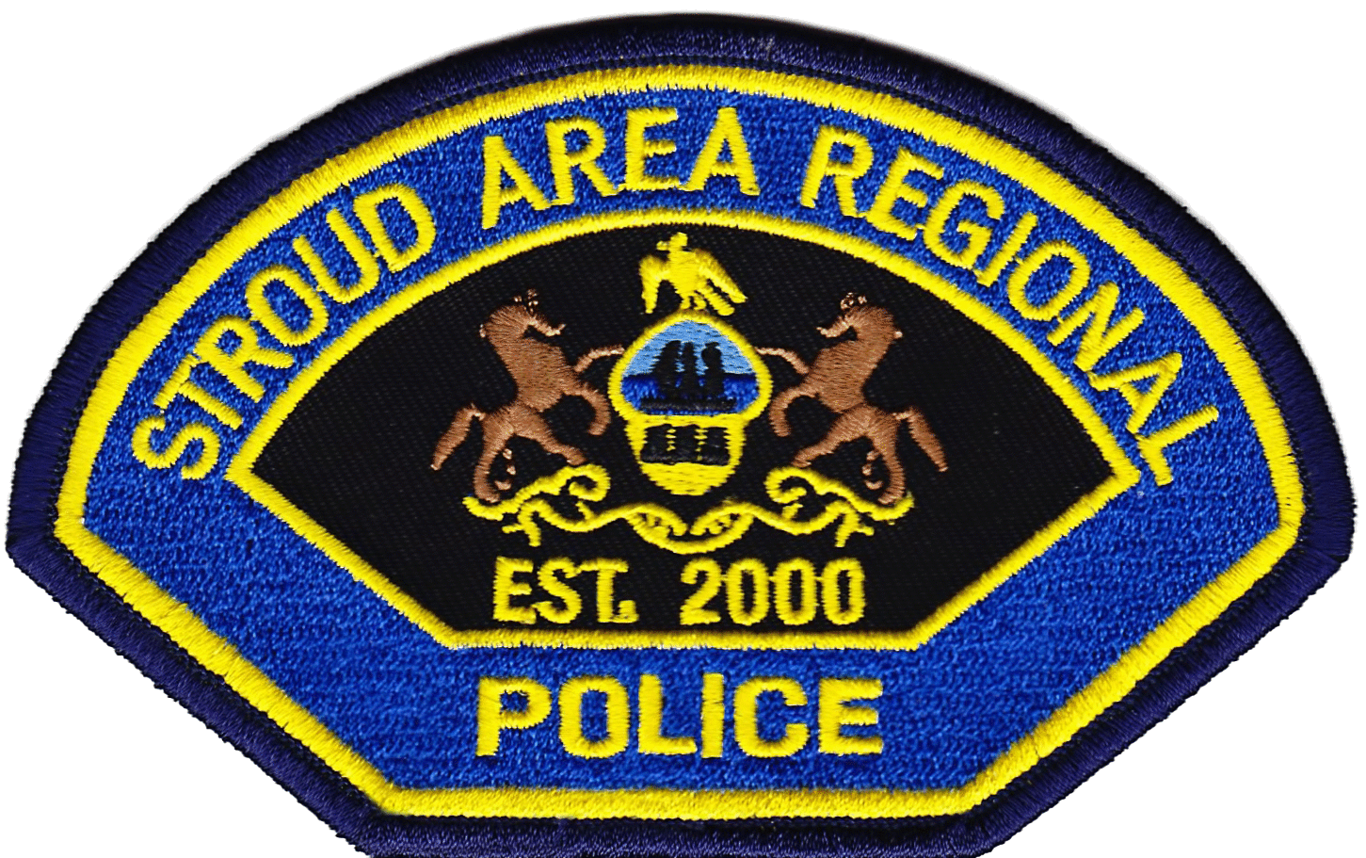8 Personal Days
* Comp. Time up to 480 hours
* 9 paid holidays
* Pension Plan
* Deferred Compensation Plans
* Life Insurance Coverage
* Education Incentive
* Health, dental and vision for the Officer and his family.

**SARPD History**

Stroud Area Regional Police Department was formed on May 1, 2000, bringing together experienced police officers from the Stroudsburg, East Stroudsburg, and Stroud Township police departments. Today, SARPD has a $9.3 million operating budget, 48 full-time officers and serves a total population of approximately 35,000 residents, in one of the fastest growing areas of the Commonwealth.

With its 49 police officers, Stroud Area Regional Police Department (SARPD) is one of the largest regional departments in the Commonwealth of Pennsylvania. Our coverage area is comprised of 39 square miles, which includes the home to East Stroudsburg University, 2 Hospitals, 2 school districts, the County Courthouse and the County Administrative buildings. In addition, Route 80 dissects through the southern half of our jurisdiction.

