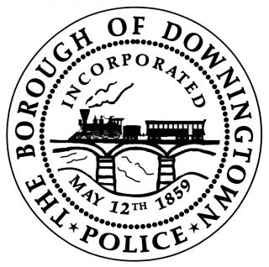
DOWNINGTOWN POLICE DEPARTMENT
SALARY AND BENEFITS INFORMATION

- Competitive Salary
(Current collective bargaining agreement covers 2026 through 2029)

- Medical, Vision and Dental after 30 days
- Educational Tuition Reimbursement after 1 year
- Paid Leave including Vacation, Holidays, Personal, and Sick
- Pension Plan, Life Insurance and Disability Insurance
- Longevity Payment for Every 5 Years of Service
- Shift Differential and Overtime Opportunities
- All Uniform and Equipment Provided
- Annual Personal Equipment Benefit

DOWNINGTOWN POLICE – STARTING SALARY INFORMATION
Officer Candidate Type | 2027 | 2028
No Training | $83,990 | $88,189
Act 120 Training - without experience | $90,450 | $94,973
Act 120 Training - WITH experience* | $103,372 to $129,215 | $108,541 to $135,676
*Per the collective bargaining agreement, the Chief of Police has the discretion
to credit a new hire with an increased starting salary schedule if he decides that
the new hire’s previous experience as a CERTIFIED POLICE OFFICER warrants such credit.

E-mail any questions to
pdrecruit@downingtown.org

