Lower Salford Township Police Department

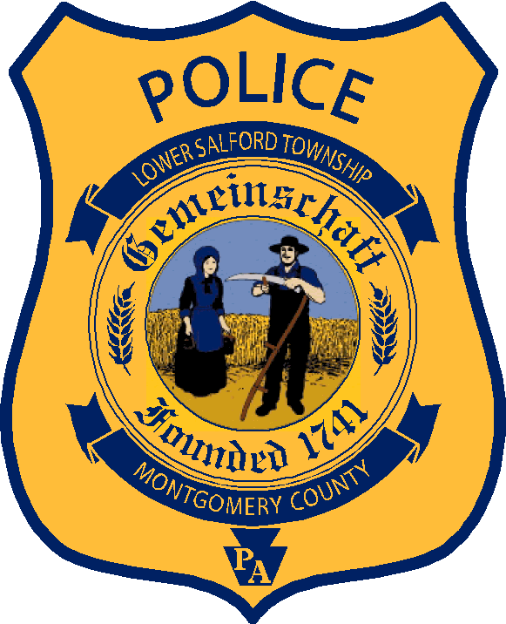
Thomas A. Medwid
Chief of Police

379 Main Street
Harleysville, PA 19438
(215) 256-9500
www.lowersalfordtownship.org
Lower Salford Township Police Department

The Hiring Process
Submit your resume now. When we initiate a hiring cycle, we will contact you and ask you to complete an employment application. A select number of applicants will be invited to participate in an interview process. The hiring process also includes an extensive background investigation, a polygraph examination, a medical evaluation, and a psychological evaluation.

Minimum Qualifications
- Minimum 21 years of age
- U.S. Citizen
- Valid PA driver’s license
- High School Diploma or GED
- No disqualifying convictions, as defined by MPOETC
- Ability to perform the core job description for Patrol Officer, as defined by MPOETC
Salary and Benefits Highlights
- 2023 Salary Range: $66,574 – 127,305
- Act 600 Pension Plan
- Generous vacation and holiday package
- 457 Deferred Compensation Plan
- Consideration for lateral entry
- Tuition reimbursement
- Longevity compensation
- Rank differential

Preferred Qualifications
- Act 120 Police Academy
- Degree in Criminal Justice or related field
- Military experience
- Fire/EMS experience
- Technology and computer skills
- Foreign language proficiency

Career Development Highlights
- Premier Accredited Law Enforcement Agency
- Community Support
- Traffic Law Enforcement
- Criminal Law Enforcement
- Tactical Response/SWAT Team
- Drug and DUI Task Forces
- Bike Patrol

