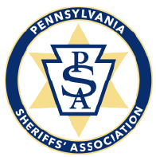 | 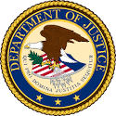

______________________________________________________________________________
The PA Sheriffs’ Association (PSA) and the United States Department of Justice (DOJ) are pleased to provide the two below training sessions on March 13, 2020 at the Wyndham Garden in Boalsburg PA during the PSA Winter conference.
Lunch will be provided by Chief Oil and Gas Company.
Please complete the below registration form and return via email or fax no later than close of business Wednesday March 4, 2020 to:
bappleby@pasheriffs.org / Fax: 717-236-7332 / Questions – call PSA at 717 236-7336

Title: National and Regional Drug Trends and Addiction 101
Instructors: Laura Hendrick, Field Intelligence Manager
Drug Enforcement Administration Philadelphia Division
Sean Fogler, MD
PA Harm Reduction Coalition
Time: 9:30 to 11:30
Title: Law Enforcement Challenges and Promising Practices
Instructors: Bill Keith, Director, DOJ Community Oriented Policing Services (COPS Office)
Tracy Trautman, Acting Director, DOJ Bureau of Justice Assistance
Time: 1:30 to 3:30
____________________________________ Name
____________________________________ Title/Position
____________________________________ Agency
Please mark your selection(s) below.
_____ National and Regional Drug Trends and Addiction 101
_____ Lunch
_____ Law Enforcement Challenges and Promising Practices

